***SOURCE CODE***

-- 1. Create a database named employee, then import data_science_team.csv proj_table.csv and emp_record_table.csv into the employee database from the given resources.

* Create database employee;

2. Create an ER diagram for the given **employee** database.

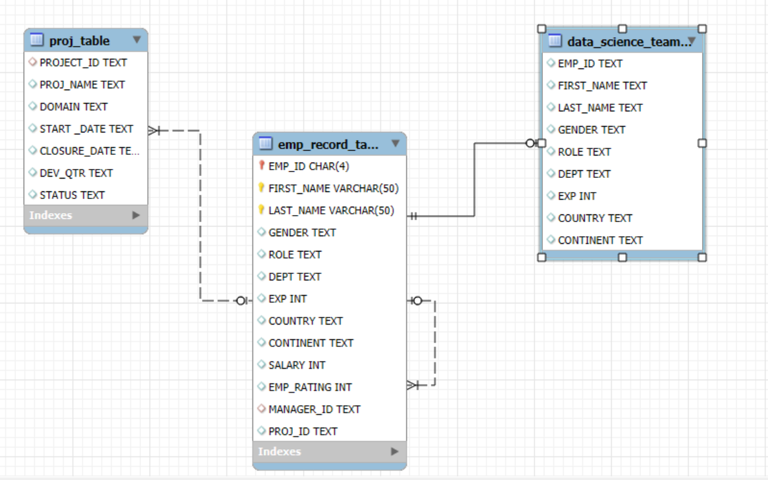

-- 3. Write a query to fetch EMP_ID, FIRST_NAME, LAST_NAME, GENDER, and DEPARTMENT from the employee record table, and make a list of employees and details of their department.

* select EMP_ID, FIRST_NAME, LAST_NAME, GENDER, DEPT

from emp_record_table order by dept;

4. Write a query to fetch EMP_ID, FIRST_NAME, LAST_NAME, GENDER, DEPARTMENT, and EMP_RATING if the EMP_RATING is:

● less than two

● greater than four

● between two and four

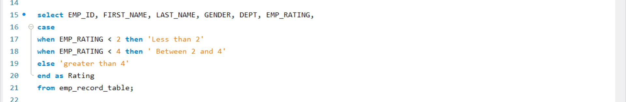

5. Write a query to concatenate the FIRST_NAME and the LAST_NAME of employees in the Finance department from the employee table and then give the resultant column alias as NAME.

* select concat(FIRST_NAME, ' ', LAST_NAME) AS NAME

from emp_record_table order by dept = 'Finance';

6. Write a query to list only those employees who have someone reporting to them. Also, show the number of reporters (including the President).

* select concat(e.First_name, " ", e.Last_name) as Name, count(m.manager_id)

from emp_record_table e join emp_record_table m

where e.EMP_ID = m.MANAGER_ID

group by Name;

7. Write a query to list down all the employees from the healthcare and finance departments using union. Take data from the employee record table.

* select * from emp_record_table where dept = "HEALTHCARE"

union

select * from emp_record_table where dept = "FINANCE";

8. Write a query to list down employee details such as EMP_ID, FIRST_NAME, LAST_NAME, ROLE, DEPARTMENT, and EMP_RATING grouped by dept. Also include the respective employee rating along with the max emp rating for the department.

* select EMP_ID, FIRST_NAME, LAST_NAME, ROLE, DEPT, EMP_RATING, max(EMP_RATING) OVER(partition by dept) from emp_record_table;

9. Write a query to calculate the minimum and the maximum salary of the employees in each role. Take data from the employee record table.

* select ROLE, min(salary) MIN_SALARY, max(salary) MAX_SALARY

from emp_record_table group by role;

10. Write a query to assign ranks to each employee based on their experience. Take data from the employee record table.

* select EMP_ID, FIRST_NAME, LAST_NAME, EXP, rank() over(order by exp desc) RankBYExp from emp_record_table;

11. Write a query to create a view that displays employees in various countries whose salary is more than six thousand. Take data from the employee record table.

* CREATE VIEW SalaryyByCountry

as

select * from emp_record_table where SALARY > 6000 order by COUNTRY;

* select * from SalaryyByCountry;

12. Write a nested query to find employees with experience of more than ten years. Take data from the employee record table.

* select * from emp_record_table where EMP_ID IN(

select EMP_ID from emp_record_table where EXP > 10);

13. Write a query to create a stored procedure to retrieve the details of the employees whose experience is more than three years. Take data from the employee record table.

* DELIMITER $$

CREATE PROCEDURE `DetailsByExp`()

BEGIN

select * from emp_record_table where exp > 3;

END$$

* call DetailsByExp;

14. Write a query using stored functions in the project table

to check whether the job profile assigned to each employee in the data science team matches the organization’s set standard.The standard being:

* For an employee with experience less than or equal to 2 years assign 'JUNIOR DATA SCIENTIST',
* For an employee with the experience of 2 to 5 years assign 'ASSOCIATE DATA SCIENTIST',
* For an employee with the experience of 5 to 10 years assign 'SENIOR DATA SCIENTIST',
* For an employee with the experience of 10 to 12 years assign 'LEAD DATA SCIENTIST',
* For an employee with the experience of 12 to 16 years assign 'MANAGER'.

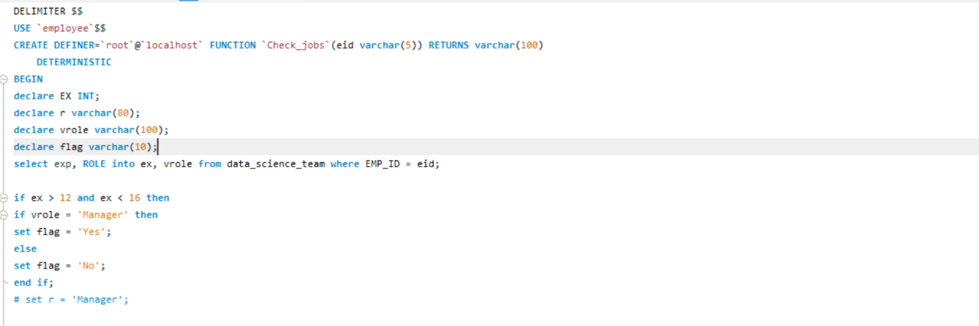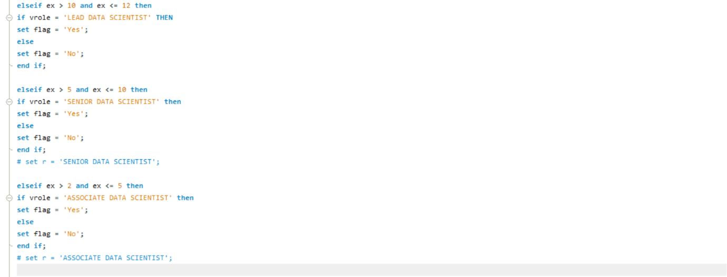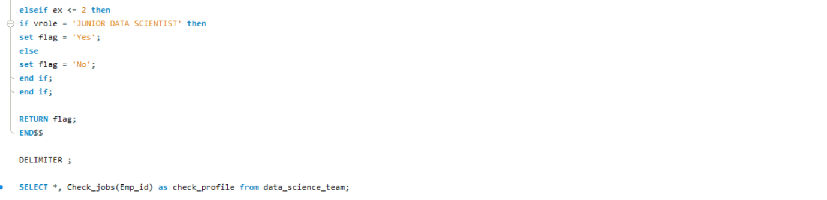

15. Create an index to improve the cost and performance of the query

to find the employee whose FIRST_NAME is ‘Eric’ in the employee table after checking the execution plan.

* + SELECT * from emp_record_table where FIRST_NAME = 'Eric';

CREATE INDEX Idx_Emp_name on emp_record_table(FIRST_NAME(10));

SELECT * from emp_record_table where FIRST_NAME = 'Eric';

16. Write a query to calculate the bonus for all the employees, based on their ratings and salaries (Use the formula: 5% of salary * employee rating).

* + SELECT EMP_ID, FIRST_NAME, LAST_NAME, EMP_RATING,

emp_rating * .05*salary as BONUS from emp_record_table;

17. Write a query to calculate the average salary distribution based on the continent and country. Take data from the employee record table.

* select CONTINENT, COUNTRY, avg (SALARY) from emp_record_table

group by CONTINENT, COUNTRY with rollup

order by CONTINENT, COUNTRY;